

Semester 2 Examination, 2012

Question/Answer Booklet

MATHEMATICS

3C/3D (Year 12)

Section Two:

Calculator-assumed

Your name:

Your teacher: S Ebert T Hosking S Rowden

Time allowed for this section
Reading time before commencing work: ten minutes
Working time for paper: one hundred minutes

Material required/recommended for this section

To be provided by the supervisor
This Question/Answer booklet
Formula sheet (retained from Section One)

To be provided by the candidate
Standard items: pens, pencils, pencil sharpener, eraser, correction/tape fluid, ruler, highlighters

Special items: drawing instruments, templates, notes on two unfolded sheets of A4 paper, and up to three calculators satisfying the conditions set by the Curriculum Council for this course.

Important note to candidates

No other items may be used in this section of the examination. It is your responsibility to ensure that you do not have any unauthorised notes or other items of a non-personal nature in the examination room. If you have any unauthorised material with you, hand it to the supervisor before reading any further.

Structure of this paper

Section | Number of questions available | Number of questions to be answered | Working time (minutes) | Marks available
Section One:  Calculator-free | 7 | 7 | 50 | 50
Section Two:  Calculator-assumed | 13 | 13 | 100 | 100
 |  |  |  | 150

Instructions to candidates

- The rules for the conduct of Western Australian external examinations are detailed in the Year 12 Information Handbook 2012. Sitting this examination implies that you agree to abide by these rules.

- Write your answers in the spaces provided in this Question/Answer Booklet. Spare pages are included at the end of this booklet. They can be used for planning your responses and/or as additional space if required to continue an answer.
- Planning: If you use the spare pages for planning, indicate this clearly at the top of the page.
- Continuing an answer: If you need to use the space to continue an answer, indicate in the original answer space where the answer is continued, i.e. give the page number. Fill in the number of the question(s) that you are continuing to answer at the top of the page.

- Show all your working clearly. Your working should be in sufficient detail to allow your answers to be checked readily and for marks to be awarded for reasoning. Incorrect answers given without supporting reasoning cannot be allocated any marks. For any question or part question worth more than two marks, valid working or justification is required to receive full marks. If you repeat an answer to any question, ensure that you cancel the answer you do not wish to have marked.

- It is recommended that you do not use pencil except in diagrams.

Section Two: Calculator-assumed (100 Marks)

This section has thirteen (13) questions. Answer all questions. Write your answers in the space provided.

Working time for this section is 100 minutes.

Question 8 (5 marks)

A rechargeable battery has a voltage of 9 volts when fully charged. When the battery is used to
run an electronic toy, the voltage V volts, remains at 9 volts for 30 minutes and then the voltage
decreases instantaneously, at a rate modelled by , where t is time in minutes.

(a) Find the net change in the battery voltage after the toy has been used for 40 min.
[3]

(b) Find how long the battery can be used to run this toy if a minimum voltage of 8 volts is
required.
[2]

Question 9 (6 marks)
A body is moving in a straight line with velocity, m/s, given by , where is the time, in seconds, since the body first passed through a fixed point P.

(a) At what other time(s), if any, does the body again pass through the fixed point P?
[3]

(b) Show that the body is stationary twice and find the distance travelled by the body between these two instants.
[3]

Question 10 (7 marks)

On the basis of the results obtained from a random sample of 81 bags produced by a mill, the 95% confidence interval for the mean weight of flour in a bag is found to be (514.56g, 520.44g).

(a) Show the value of , the mean weight of the sample is 517.5 g.
[1]

(b) Find the value of , the standard deviation of the normal population from which the sample is drawn.
[2]

(c) Calculate the 99% confidence interval for the mean weight of flour in a bag.
[2]

(d) Using the sample mean from (a) as the best estimate for the population mean, what is the probability that the sample mean of a larger sample of 225 bags is less than 516 g?
[2]

Question 11 (7 marks)

Atmospheric pressure, (kPa), decreases approximately exponentially with increasing height (m), above sea level according to the relationship , where is a constant. Atmospheric pressure at sea level is 101.3 kPa, and halves with every 5 800 m increase in height.

(a) Find the value of, rounded to four significant figures.
[2]

(b) Calculate the atmospheric pressure at the top of a mountain of height 3 785 m.
[2]

(c) Use the increments formula to find the approximate change in pressure as a climber descends 250 m from the top of a mountain of height 3 785 m.
[3]

Question 12 (9 marks)

(a) Even numbers are to be formed using some, or all, of the digits 5, 6, 7, 8 and 9.

(i) How many even numbers can be formed in this way, if repetition of digits is not allowed?
[3]

(ii) What fraction of the numbers in (i) start with a 9?
[2]

(b) The journey time for a driver between two depots is normally distributed with mean of 55 minutes and standard deviation of 4.5 minutes.

(i) If the driver makes four journeys every day, for five days a week, and for 48 weeks each year, how many of these journeys take less than an hour?
[2]

(ii) What is the probability that a journey takes at least an hour, given that it takes less than 65 minutes?
[2]

Question 13 (12 marks)

(a) A pottery produces souvenir coffee mugs, of which it is known that 5% are defective.

(i) In a box of 24 mugs, what is the probability that there are at least 4 defectives?
[2]

(ii) In a box of 12 mugs, what is the probability that there are no defectives?
[1]

(iii) What is the probability that in 10 boxes, each containing 12 mugs, that either two or three of the boxes contain no defectives?
[2]

(iv) The pottery decides to pack n mugs per box for wholesale clients, so that the chance of there being at least one defective mug in a box is no more than 50%. Find the largest value of n.
[2]

Question 13 (continued)

(b) A worker at the pottery took 150 of the defective mugs, filled them with soil and then planted four seeds in each. After 14 days, the number of seeds which germinated in each of the mugs was noted, with these results:

Number of germinating seeds | 0 | 1 | 2 | 3 | 4
Number of mugs | 1 | 9 | 16 | 57 | 67

(i) What is the mean number of seeds germinating per mug?
[1]

(ii) Show the probability of one seed germinating is 0.8.
[1]

(iii) Use an associated binomial distribution to calculate the theoretical frequency distribution for the number of seeds germinating in the 150 mugs and comment on how well your distribution models the observed results above.
[3]

Question 14 (10 marks)

(a) A spherical snowball is melting at a rate of 18 000 cm³ per hour. At the instant the
volume of the snowball is 4 000 cm³, calculate the rate of change of radius of the
snowball, in cm per minute.
[4]

Question 14 (continued)

(b) (i) The area enclosed by the parabola with equation, the x-axis and the lines
x = 0 and x = 2 rotates about the x-axis. Show that the volume of this solid is
one fifth the volume of the circumscribed cylinder.
[3]
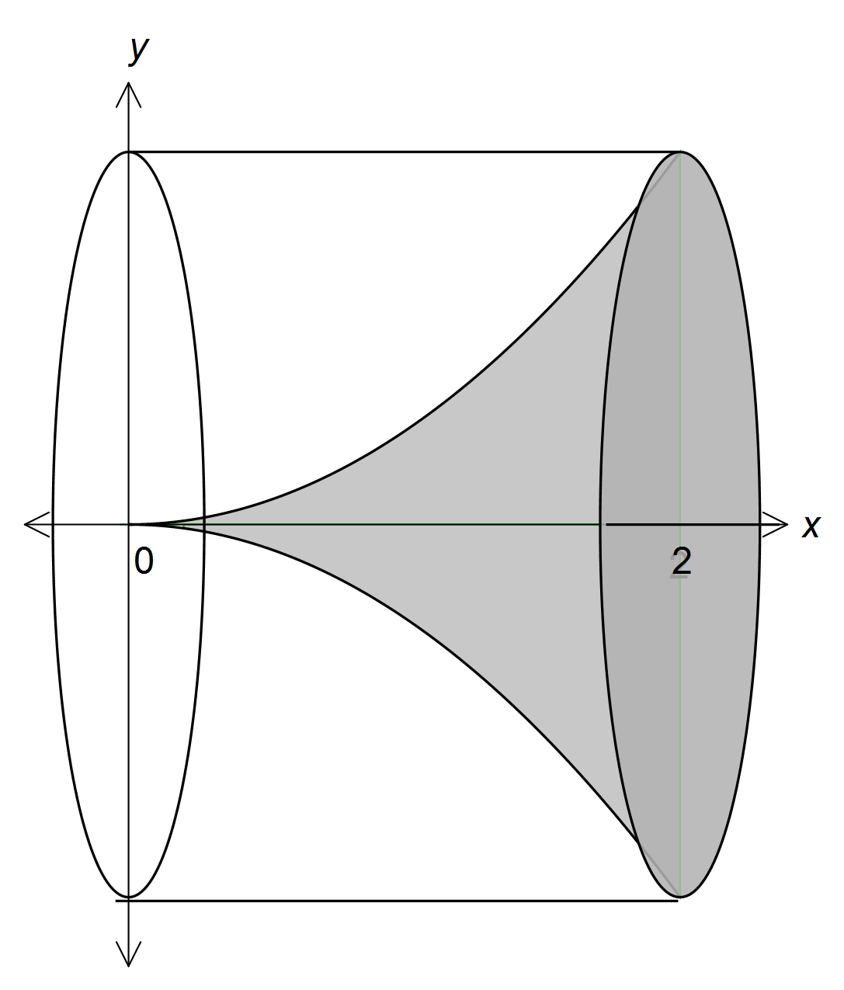

(ii) Hence, or otherwise, prove that the volume of the solid formed when rotating about the x-axis the area enclosed by the parabola with equation, the
x-axis and the lines x = 0 and x = a, where a is a positive constant, will be one fifth the volume of the circumscribed cylinder.
[3]

Question 15 (9 marks)

At the end of a technology course, all students sat a practical and a theory examination, with 20% achieving a distinction in the practical examination, 3% of students achieving distinctions in both examinations and 76% achieving no distinction in either examination.

(a) What is the probability that a student chosen at random from the course achieved a distinction in the theory examination?
[4]

(b) Are the events 'achieving a distinction in the practical examination' and 'achieving a distinction in the theory examination' independent? Explain your answer.
[2]

(c) In a group of 14 students who took the course, three achieved a distinction in the practical examination. If five students are selected at random from this group, what is the probability that at least two of them achieved a distinction in the practical examination?
[3]

Question 16 (5 marks)

A continuous random variable has the probability distribution function ,

(a) Calculate

(i) .
[1]

(ii) .
[2]

(b) If , find the value of .
[2]

Question 17 (9 marks)

The feasible region of a linear programming problem is shown below.
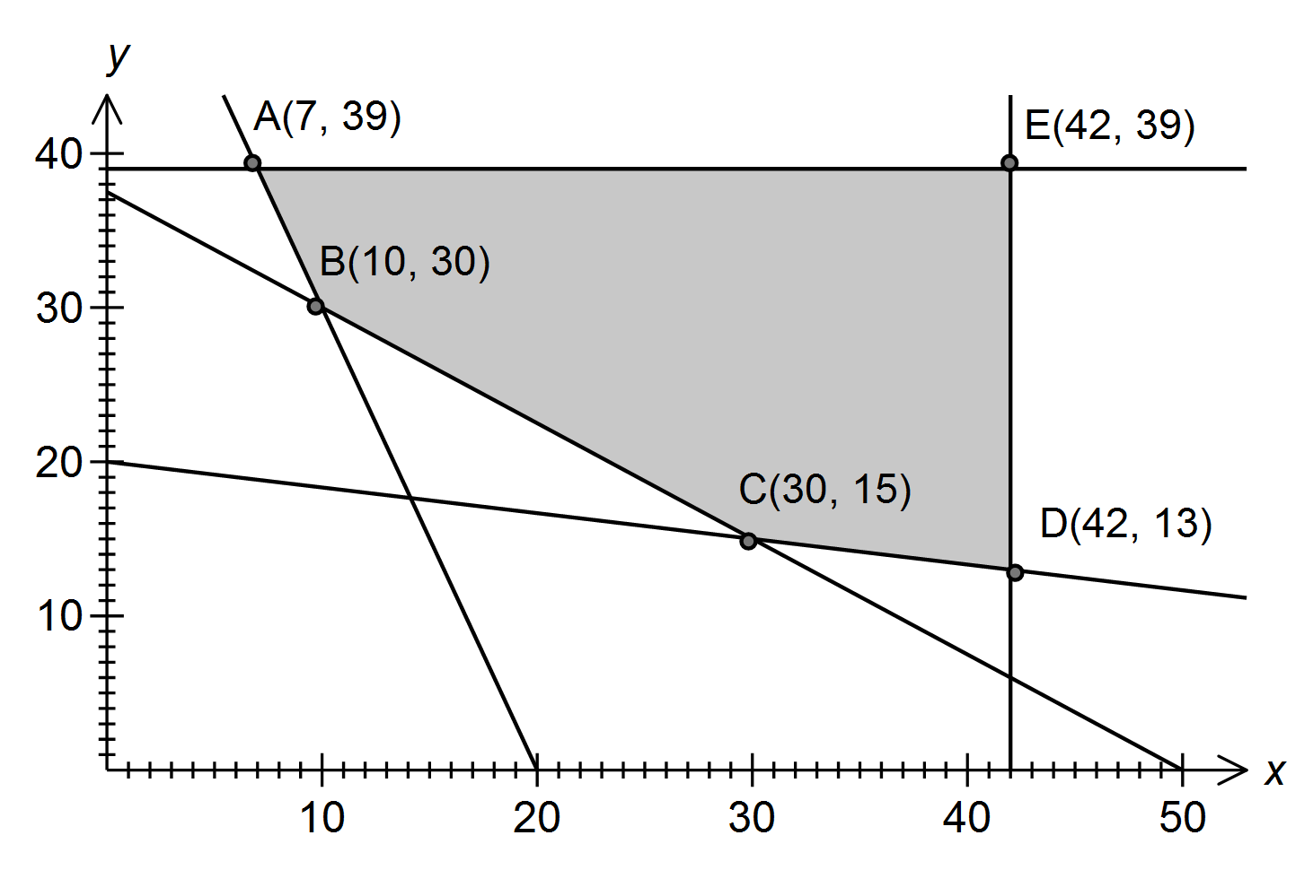

The objective function is .

(a) Determine the inequality satisfied by x and y that corresponds to the edge AB of the feasible region.
[2]

(b) Determine the maximum value of Q in the feasible region.
[1]

(c) Determine the minimum value of Q in the feasible region.
[1]

Question 17 (continued)

(d) The objective function is changed to .

What is the minimum possible value of the constant a, given that the minimum value of Q still occurs at the same corner point?
[3]

(e) An additional constraint is imposed. How does this additional constraint affect the minimum value of Q in the feasible region?
[2]

Question 18 (10 marks)

Let and , where x and y are integers.

(a) Evaluate A and B when and .
[1]

(b) The parity of an object states whether it is even or odd. Complete these tables for the parity of the product and difference of odd and even numbers.

 | odd | even |  |  | odd | even
odd | odd | even |  | odd | even | odd
even |  |  |  | even

[2]

(c) Examine the parity of A and B for various values of x and y, and hence state a conjecture about the parity of B when A is even.
[3]

Question 18 (continued)

(d) Prove the conjecture in part (c).
[4]

Question 19 (5 marks)

In the diagram, is a right-angled triangle with and M is the midpoint of PR.
N is the point where the perpendicular to PR at M meets QR.

(a) Prove that .
[2]

(b) If PN bisects , show that the ratio of the areas of is .
[3]

Question 20 (6 marks)

A function is such that .

(a) State the x-coordinate of the minimum of .
[2]

(b) Justify that has a point of inflection when .
[2]

(c) Find .
[2]

Additional working space

Question number(s):

Additional working space

Question number(s):

Additional working space

Question number(s):

